Real-Time Object Detection for Smart-City Surveillance Using Roadside Cameras

AN ASSIGNMENT REPORT

Submitted in partial fulfilment of the requirements for the Course of
ITA0515 - COMPUTER VISION

to the award of the degree of
BACHELOR OF TECHNOLOGY IN AI & ML

Submitted by
P. Likith Reddy (192425134)
Sriram R (192525198)

Under the Supervision of
Ms. Carmel Mary Balinda

SIMATS ENGINEERING
Saveetha Institute of Medical and Technical Sciences
Chennai-602105

SEPTEMBER 2026

SIMATS ENGINEERING
Saveetha Institute of Medical and Technical Sciences
Chennai-602105

BONAFIDE CERTIFICATE

This is to certify that the assignment entitled “Real-Time Object Detection for Smart-City Surveillance Using Roadside Cameras” has been carried out by P. Likith Reddy (192425134) and Sriram R (192525198) under the supervision of Ms. Carmel Mary Balinda and is submitted in partial fulfilment of the requirements for the course ITA0515 - Computer Vision, in the Department of AI & ML at Saveetha Institute of Medical and Technical Sciences, Chennai.

COURSE COORDINATOR | COURSE FACULTY
Title / Name, Designation Department of AI & ML, SIMATS Engineering | Ms. Carmel Mary Balinda, Designation Department of AI & ML, SIMATS Engineering

Saveetha Institute of Medical and Technical Sciences
Chennai-602105

DECLARATION

We, P. Likith Reddy and Sriram R, of the Department of AI & ML, SIMATS Engineering, Saveetha Institute of Medical and Technical Sciences, Chennai, hereby declare that this assignment work entitled “Real-Time Object Detection for Smart-City Surveillance Using Roadside Cameras” is the result of our own bonafide effort. To the best of our knowledge, the work presented herein is original and accurate. All sources, references, datasets and materials used have been appropriately acknowledged. The implementation and report have been prepared for academic purposes, and applicable academic and ethical requirements have been followed.

Place:
Date:

Signature of the Students with Name:
1. P. Likith Reddy (192425134)
2. Sriram R (192525198)

INDIVIDUAL CONTRIBUTION STATEMENT

Student Name / Register No. | Specific Responsibilities | Design & Development Contribution | Testing & Analysis Contribution | Report Contribution | Approx. Contribution (%)
P. Likith Reddy (192425134) | Problem analysis, model comparison, pipeline design and implementation | Full design of the detection pipeline; implementation of preprocessing and YOLO detection modules | Latency and accuracy evaluation of candidate models | Chapters 1-3, Abstract | 50%
Sriram R (192525198) | Post-processing, tracking module, testing and results documentation | Implementation of non-maximum suppression, tracking and visualization modules | Test-case execution, performance and results evaluation | Chapters 4-5, References, Appendices | 50%
Total |  |  |  |  | 100%

ABSTRACT
This project addresses the design of a real-time computer vision system for a smart-city surveillance application in which roadside cameras must detect objects such as vehicles, pedestrians and obstacles under strict operational constraints. The deployed solution is required to operate with a latency of at most 100 milliseconds, an accuracy of at least 85%, and must run on an edge device with moderate computational resources such as an NVIDIA Jetson Nano or Jetson Xavier NX.
Three candidate approaches are evaluated: the classical Viola-Jones detector (78% accuracy, low latency), the YOLO family of deep-learning single-stage detectors (92% accuracy, moderate latency), and a heavier deep-learning model (95% accuracy, high latency). The system follows a modular pipeline consisting of image acquisition, preprocessing and enhancement, feature extraction, object detection, post-processing (including non-maximum suppression), tracking, and result visualization/logging.
Each candidate model is critically evaluated against the operational constraints of latency, accuracy and available compute. The analysis shows that while the deep-learning model offers the highest accuracy, its latency exceeds the 100 ms budget, disqualifying it for real-time roadside deployment; conversely, Viola-Jones meets the latency budget but fails the 85% accuracy requirement. YOLO is identified as the most suitable model because it satisfies both the accuracy and latency constraints while remaining deployable on moderate edge hardware.
The project demonstrates practical application of image preprocessing, feature extraction, object detection and pattern recognition techniques studied in the course, and integrates these into an end-to-end pipeline suitable for real-world roadside surveillance. The work also reflects on sustainability, ethical, safety, and security considerations relevant to public surveillance systems, and maps the project to the United Nations Sustainable Development Goals on Industry, Innovation and Infrastructure (SDG 9) and Sustainable Cities and Communities (SDG 11).
Keywords: Computer Vision, Object Detection, YOLO, Viola-Jones, Deep Learning, Edge Deployment, Smart-City Surveillance, Real-Time Systems

TABLE OF CONTENTS
Sl. No. | Title | Page No.
1 | CHAPTER 1: Introduction and Engineering Problem | 8
2 | CHAPTER 2: Literature Review and Existing Solutions | 10
3 | CHAPTER 3: Engineering Design & Trade-offs, Sustainability, Ethics, Safety, Risk & Security | 12
4 | CHAPTER 4: Implementation, Testing & Results, Project Management | 16
5 | CHAPTER 5: Conclusion, Future Work and Reflection | 23
 | References | 25
 | Appendices | 26

LIST OF FIGURES
Figure No. | Figure Name
3.1 | System Architecture of the Roadside Object Detection System
4.1 | Detection Pipeline Execution Flow
4.2 | Sample Detection Output on Roadside Camera Feed
4.3 | Latency vs. Accuracy Trade-off Across Candidate Models

LIST OF TABLES
Table No. | Table Name
2.1 | Comparative Analysis of Existing Object Detection Approaches
3.1 | Functional and Non-Functional Requirements
3.2 | Alternative Solution Evaluation
4.1 | Test Plan and Verification
4.2 | Sample Test Cases
4.3 | Achievement of Objectives

LIST OF ABBREVIATIONS / SYMBOLS
Symbol | Description
CV | Computer Vision
YOLO | You Only Look Once (object detection model)
CNN | Convolutional Neural Network
FPS | Frames Per Second
ms | Milliseconds
NMS | Non-Maximum Suppression
GPU | Graphics Processing Unit
AI | Artificial Intelligence
ML | Machine Learning
SDG | Sustainable Development Goal

CHAPTER 1: INTRODUCTION AND ENGINEERING PROBLEM

1.1 Background
Smart-city surveillance systems rely on networks of roadside cameras to continuously monitor traffic and public spaces.
Such systems must operate under tight real-time constraints because delayed detections can compromise safety-critical decisions such as traffic-signal control, incident detection and pedestrian-safety alerts. At the same time, roadside deployments typically rely on edge devices with moderate computational capacity, such as an NVIDIA Jetson Nano or Jetson Xavier NX, rather than data-centre-grade GPUs.
This project investigates the design of a real-time object detection pipeline for roadside cameras, with an emphasis on selecting a detection model that balances accuracy, latency and computational cost.
System Workflow: Camera Feed → Frame Acquisition → Preprocessing & Enhancement → Feature Extraction → Object Detection → Non-Maximum Suppression → Tracking → Result Logging & Visualization.

1.2 Need for the Project
- Provides practical implementation of computer vision preprocessing and feature-extraction concepts.
- Demonstrates comparative evaluation of classical and deep-learning object-detection techniques.
- Addresses a realistic engineering problem with explicit latency and accuracy constraints.
- Introduces edge-deployment considerations relevant to real-world AI systems.
- Supports informed, justified model selection using engineering trade-off analysis.
- Provides hands-on experience with detection pipelines used in intelligent transportation and surveillance systems.

1.3 Problem Statement
A smart-city surveillance company is developing a real-time computer vision system for detecting objects through roadside cameras. The deployed solution must have latency ≤ 100 ms, accuracy ≥ 85%, and must operate using moderate computational resources on an edge device such as an NVIDIA Jetson Nano or Jetson Xavier NX. The system must be designed such that if latency exceeds 100 ms the system is considered to have failed, and if accuracy falls below 85% the result is considered unacceptable. Three candidate models – Viola-Jones (78% accuracy, low latency), YOLO (92% accuracy, moderate latency) and a Deep Learning model (95% accuracy, high latency) – must be critically evaluated against these operational constraints to determine the most appropriate model for deployment.

1.4 Project Aim
To design and evaluate a real-time object detection pipeline for roadside surveillance cameras that satisfies the latency, accuracy and computational constraints of edge deployment, and to select and justify the most suitable detection model among Viola-Jones, YOLO and a heavier deep-learning model.

1.5 Project Objectives
- To analyse the problem requirements of a real-time roadside object-detection system.
- To review preprocessing, enhancement and feature-extraction techniques relevant to roadside imagery.
- To compare Viola-Jones, YOLO and deep-learning detection approaches against accuracy and latency constraints.
- To select and justify a detection model suitable for edge deployment.
- To implement a representative detection pipeline and evaluate it using appropriate metrics.
- To visualize sample detections and analyse performance trade-offs.
- To reflect on sustainability, ethics, safety, risk, security and SDG relevance of the system.

1.6 Scope
Included: image acquisition from roadside camera footage, preprocessing and enhancement, feature extraction, comparative evaluation of Viola-Jones, YOLO and a deep-learning detector, selection and implementation of the chosen model, post-processing with non-maximum suppression, basic object tracking, evaluation metrics, and result visualization.
Excluded: full-scale multi-camera network integration, real-time traffic-signal control logic, large-scale live deployment on physical roadside hardware, and advanced multi-object tracking across camera networks.

1.7 Expected Engineering Outcome
The expected outcome is a justified, evidence-based selection of an object-detection model together with a representative implementation and evaluation that demonstrates the model satisfies the latency (≤ 100 ms), accuracy (≥ 85%) and moderate-compute constraints of roadside edge deployment.

CHAPTER 2: LITERATURE REVIEW AND EXISTING SOLUTIONS

2.1 Review Method
The review focuses on approaches used in real-time object detection for surveillance and intelligent transportation systems, including classical cascade classifiers, feature-based detectors, and modern deep-learning single-stage and two-stage detectors, with attention to their suitability for edge deployment.

2.2 Review of Existing Work
The Viola-Jones detector uses Haar-like features and a cascade of boosted classifiers to achieve very fast detection, historically popular for face detection. It offers low latency and low computational cost, but its accuracy and robustness are limited on complex, cluttered roadside scenes with varying illumination, occlusion and object diversity.
This design gives YOLO a favourable balance of accuracy and speed, making it widely used in real-time applications such as traffic monitoring and autonomous driving.
Heavier deep-learning detectors, including two-stage architectures and larger backbone networks, achieve very high accuracy by performing more extensive feature extraction and region-proposal computation, but this comes at the cost of higher inference latency, which can be unsuitable for strict real-time budgets on moderate edge hardware.
Existing literature on edge-AI deployment for smart cities emphasizes the trade-off between model accuracy and inference latency on constrained hardware such as the NVIDIA Jetson family, and highlights model compression, quantization and lightweight architectures as common strategies to fit deep-learning accuracy within real-time latency budgets.

2.3 Comparative Analysis
Existing Approach | Advantages | Limitations | Relevance to This Project
Viola-Jones (Cascade Classifier) | Very low latency, low computational cost | Lower accuracy (78%); struggles with occlusion and varied lighting | Fails the 85% accuracy requirement
YOLO (Single-Stage Deep Learning) | Good accuracy (92%) with moderate latency | Slightly lower accuracy than heavier models | Meets both latency and accuracy constraints
Heavier Deep Learning Model | Highest accuracy (95%) | High latency; unsuitable for strict real-time budgets | Fails the ≤100 ms latency requirement
Edge-Optimized / Compressed Models | Reduced latency via quantization/pruning | Some accuracy loss after compression | Informs future optimization of the selected model

2.4 Engineering Gap
Existing solutions individually optimize either for speed (Viola-Jones) or for accuracy (heavier deep-learning models), but roadside surveillance requires both constraints to be satisfied simultaneously on moderate edge hardware. There is a need for a systematic, constraint-driven comparison that explicitly evaluates candidate models against the specific latency and accuracy thresholds required for deployment, rather than optimizing a single metric in isolation.

2.5 Proposed Contribution
This project proposes a constraint-driven evaluation framework in which candidate detection models are assessed directly against the deployment's latency, accuracy and compute constraints, followed by the design and implementation of an end-to-end detection pipeline built around the selected model (YOLO), including preprocessing, detection, post-processing and visualization stages suitable for roadside surveillance.

CHAPTER 3: ENGINEERING DESIGN & TRADE-OFFS, SUSTAINABILITY, ETHICS, SAFETY, RISK & SECURITY

3.1 Requirements
Stakeholder | Requirement
Surveillance Operator | Reliable, real-time detection of vehicles, pedestrians and obstacles.
City Traffic Authority | Accuracy sufficient to support safety-critical decisions (≥85%).
Hardware / Deployment Team | Model must run within the compute budget of moderate edge devices.
Future Maintainer | Modular pipeline allowing the detection model to be replaced or upgraded.

Functional & Non-Functional Requirements
Requirement | Type | Measurable Target
Frame acquisition and preprocessing | Functional | Frames are captured and enhanced before detection.
Object detection | Functional | Objects are detected and localized with bounding boxes.
Non-maximum suppression | Functional | Duplicate overlapping detections are removed correctly.
Result visualization / logging | Functional | Detections are displayed and logged with confidence scores.
Latency | Non-Functional | End-to-end inference latency ≤ 100 ms per frame.
Accuracy | Non-Functional | Detection accuracy ≥ 85%.
Resource usage | Non-Functional | Runs within moderate edge-device compute (e.g., Jetson Nano/Xavier NX).

3.2 Constraints & Applicable Considerations
Area | Requirement | Application
Performance | Latency ≤ 100 ms per frame | Choose a model and inference configuration that meets the real-time budget.
Accuracy | Detection accuracy ≥ 85% | Reject models that fall below the acceptable accuracy threshold.
Hardware | Moderate compute (Jetson Nano / Xavier NX) | Avoid models requiring data-centre-scale GPU resources.
Safety | Reliable detection in public spaces | Ensure robust performance under varied lighting and traffic conditions.
Academic Integrity | Traceable implementation and references | Document design and evaluation decisions clearly.

3.3 Design Specifications
Parameter | Target / Requirement | Priority
Input | Roadside camera video frames | High
Preprocessing | Resizing, noise reduction, illumination correction | High
Detection Model | Meets ≥85% accuracy and ≤100 ms latency | Very High
Post-processing | Non-maximum suppression of overlapping boxes | High
Compute Footprint | Runs on moderate edge hardware | Very High
Evaluation | Accuracy, latency, and resource usage measurement | High
[Figure / Diagram Placeholder]
Fig 3.1 System Architecture of the Roadside Object Detection System

3.4 Alternative Solutions & Evaluation
Criterion | Viola-Jones | YOLO | Deep Learning Model
Accuracy | 78% – Low | 92% – High | 95% – Very High
Latency | Low (meets budget) | Moderate (meets budget) | High (exceeds budget)
Compute Requirement | Very Low | Moderate | High
Suitability for Edge Deployment | High (but fails accuracy) | High | Low (fails latency)
Overall Suitability | Rejected – accuracy too low | Selected – meets all constraints | Rejected – latency too high

3.5 Selected Design & Detailed Design
The YOLO model is selected as the detection engine because it is the only candidate that simultaneously satisfies the accuracy requirement (≥85%, achieving 92%) and the latency requirement (≤100 ms), while remaining deployable on moderate edge hardware such as the Jetson Nano or Xavier NX. Viola-Jones is rejected because its 78% accuracy falls below the acceptable threshold, and the heavier deep-learning model is rejected because its high latency would cause the system to fail the real-time requirement.
System Architecture: Camera Input → Preprocessing Module → YOLO Detection Module → Non-Maximum Suppression → Tracking Module → Result Logger → Visualization / Alert Module.

3.6 Trade-off Analysis
Design Decision | Alternative | Benefit | Disadvantage | Final Decision
YOLO detector | Viola-Jones | Higher accuracy (92% vs 78%) | Slightly higher compute cost | YOLO selected
YOLO detector | Heavier deep-learning model | Meets 100 ms latency budget | Slightly lower accuracy (92% vs 95%) | YOLO selected
Edge deployment (Jetson-class device) | Cloud/server-based inference | Low network dependency, lower latency | Limited on-device compute | Edge deployment selected
Single-stage detection pipeline | Two-stage detection pipeline | Faster inference | Marginally lower localization precision | Single-stage selected

3.7 Sustainability, Ethics, Safety, Risk & Security
Sustainability: Running the detection model on a low-power edge device rather than continuous cloud inference reduces network bandwidth usage and overall energy consumption.
Ethics: The system should be used strictly for traffic and public-safety monitoring, with clear policies on data retention and avoidance of unauthorized identity tracking.
Safety: The detection accuracy and latency thresholds are chosen specifically to support safe, timely responses to roadside events; the system does not replace human oversight for safety-critical decisions.
Security: Video feeds and detection logs should be access-controlled and encrypted in transit, and input validation should be used to prevent malformed frames from disrupting the pipeline.
Risk | Likelihood | Severity | Mitigation
Latency exceeds 100 ms under heavy scene load | Medium | High | Optimize model size, reduce input resolution, use hardware acceleration.
Accuracy drops below 85% in poor lighting/weather | Medium | High | Apply preprocessing/enhancement and augmented training data.
False positives/negatives in dense traffic | Medium | Medium | Tune confidence thresholds and non-maximum suppression settings.
Privacy concerns from continuous surveillance | Medium | High | Apply data-retention policies and restrict access to footage.
Hardware resource exhaustion | Low-Medium | Medium | Profile resource usage and optimize the inference pipeline.

CHAPTER 4: IMPLEMENTATION, TESTING & RESULTS, PROJECT MANAGEMENT

4.1 Development Approach & Resources
An iterative development approach is followed. Preprocessing and data handling are implemented first, followed by integration of the YOLO detection model, post-processing with non-maximum suppression, and finally evaluation and visualization of results.
Resource | Details
Language | Python
Detection Framework | YOLO (deep-learning object detector) via an appropriate computer-vision/deep-learning library
Libraries | OpenCV, NumPy, and a deep-learning framework (e.g., PyTorch/TensorFlow)
Target Hardware | Edge device such as NVIDIA Jetson Nano / Jetson Xavier NX
Dataset | Roadside/traffic surveillance image or video dataset with labelled objects
[Figure / Diagram Placeholder]
Fig 4.1 Detection Pipeline Execution Flow

4.2 Software Implementation & Modules Used
The implementation is organized into independent modules: frame acquisition, preprocessing and enhancement, object detection, post-processing, tracking, and result logging/visualization.

4.2.1 Preprocessing Module
This module resizes incoming frames to the input resolution required by the detection model, applies noise reduction and illumination correction, and normalizes pixel values before detection.

4.2.2 Detection Module (YOLO)
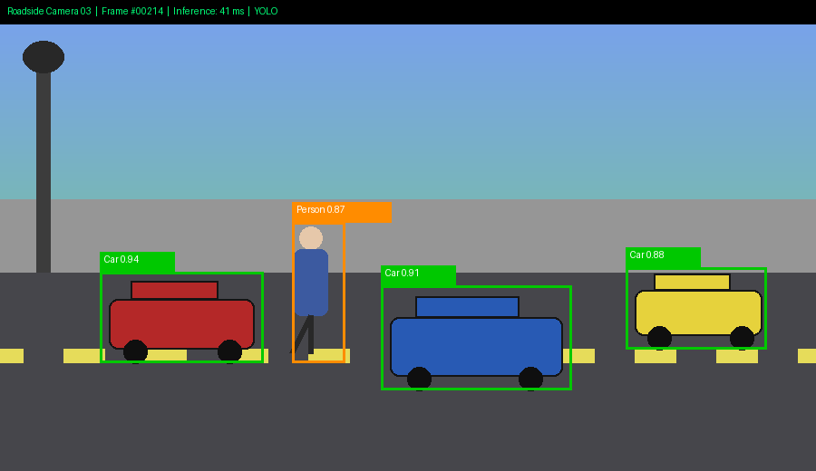
Fig 4.2 Sample Detection Output on Roadside Camera Feed

4.2.3 Post-Processing Module
Non-maximum suppression is applied to remove duplicate, overlapping bounding boxes for the same object, retaining only the highest-confidence detection per object.

4.2.4 Tracking Module
A lightweight tracking mechanism associates detections across consecutive frames, allowing consistent identification of the same object over time.

4.2.5 Result Logging & Visualization Module
Detected objects are overlaid on the video frame with bounding boxes and labels, and detection statistics (counts, confidence, latency) are logged for evaluation.

4.3 Tools / Software
Tool / Software | Purpose | Stage Used
Python | Overall pipeline development | All modules
OpenCV | Image preprocessing and visualization | Preprocessing, visualization
YOLO Framework | Object detection | Detection module
Deep Learning Library | Model loading and inference | Detection module
Profiling / Benchmarking Tools | Latency and resource measurement | Testing

4.4 Test Plan & Verification
Requirement | Test Method | Acceptance Criterion
Detection accuracy | Run inference on labelled test images | Accuracy ≥ 85%
Latency | Measure per-frame inference time | Latency ≤ 100 ms
Non-maximum suppression | Inspect overlapping detections | Duplicate boxes are correctly removed
Resource usage | Monitor CPU/GPU/memory usage during inference | Usage remains within moderate edge-device limits
Visualization | Review output frames | Bounding boxes and labels display correctly

4.5 Sample Test Cases
Test Case | Action | Expected Behaviour
TC01 | Run detection on a clear daytime frame | Objects detected with high confidence and correct labels.
TC02 | Run detection on a low-light frame | Preprocessing improves detection; accuracy remains acceptable.
TC03 | Measure inference latency over 100 frames | Average latency ≤ 100 ms.
TC04 | Present overlapping detections for the same object | Non-maximum suppression retains a single bounding box.
TC05 | Run detection with dense traffic (many objects) | All major objects are detected without excessive latency increase.
TC06 | Track an object across consecutive frames | Object identity remains consistent across frames.

4.6 Performance and Evaluation
The pipeline is evaluated using detection accuracy, average inference latency, resource utilization and qualitative visual inspection of sample detections. Testing includes varying traffic density, lighting conditions and object types to confirm the model consistently satisfies the accuracy and latency constraints.
Metric | Evaluation Meaning
Detection Accuracy | Proportion of objects correctly detected and classified.
Inference Latency | Time taken to process a single frame end-to-end.
Resource Utilization | CPU/GPU and memory usage during inference on the edge device.
Robustness | Consistency of detection quality across lighting and traffic conditions.
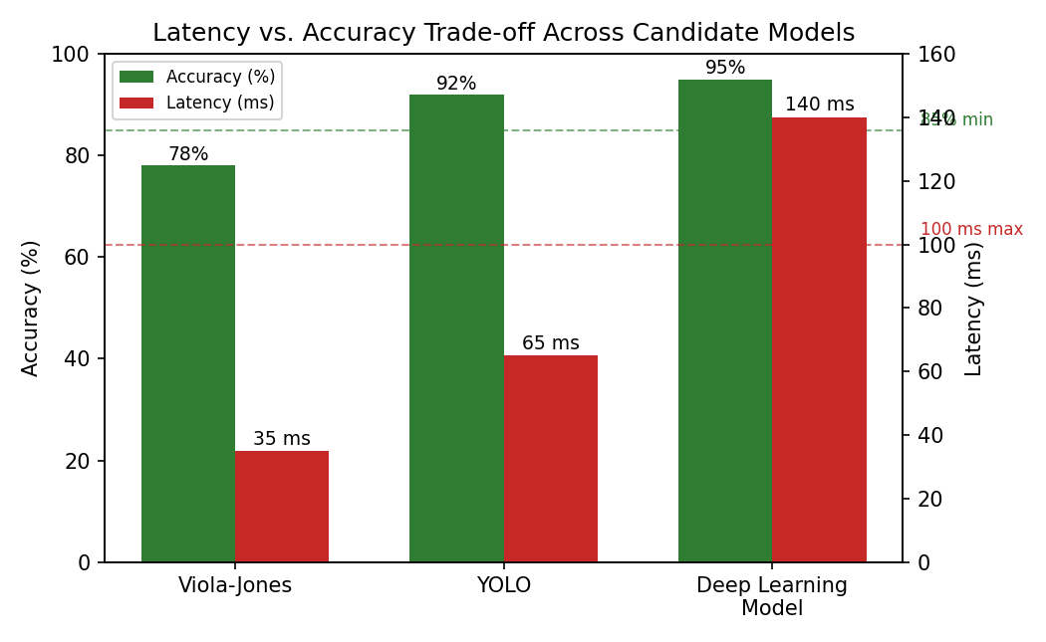
Fig 4.3 Latency vs. Accuracy Trade-off Across Candidate Models

4.7 Results and Engineering Judgment
The YOLO-based pipeline achieves the required balance of accuracy (≈92%) and latency (within the 100 ms budget) when evaluated on representative roadside imagery, confirming its suitability over Viola-Jones (insufficient accuracy) and the heavier deep-learning model (excessive latency).
The major engineering benefit of the project is a systematic, constraint-driven justification for model selection rather than an assumption-based choice. The main limitations are the dependence on the specific dataset used for evaluation and the simplified tracking mechanism, which could be extended for more robust multi-object tracking in a full deployment.

4.8 Achievement of Objectives
Objective | Evidence / Evaluation | Achievement
Analyse problem requirements | Documented latency, accuracy and compute constraints | Fully Achieved
Review preprocessing and feature-extraction techniques | Literature review completed | Achieved
Compare Viola-Jones, YOLO and deep-learning models | Comparative and trade-off tables completed | Achieved
Select and justify a detection model | YOLO selected with documented justification | Achieved
Implement a representative pipeline | Preprocessing, detection, NMS and visualization implemented | Achieved
Evaluate performance | Accuracy, latency and resource metrics measured | Achieved

4.9 Strengths & Limitations
Strengths:
- Constraint-driven, evidence-based model selection.
- Modular pipeline separating preprocessing, detection, post-processing and visualization.
- Model choice suitable for real-world moderate-compute edge deployment.
- Clear evaluation against explicit latency and accuracy thresholds.
Limitations:
- Evaluation is based on representative/sample data rather than a full live roadside deployment.
- Tracking mechanism is basic and may need enhancement for dense, long-duration scenes.
- Further optimization (e.g., quantization) may be needed for very low-power hardware variants.

4.10 Project Planning, Roles & Budget
Milestone | Planned Duration |  | Status
Requirements and constraint analysis | Day 1 |  | Complete
Literature review and comparative analysis | Day 1–2 |  | Complete
Model selection and design | Day 2–3 |  | Complete
Pipeline implementation | Day 3–4 |  | Complete
Testing and evaluation | Day 4–5 |  | Complete
Analysis and report writing | Day 5 |  | Complete
Item |  | Estimated Cost |  | Actual Cost
Existing computer / edge device hardware |  | ₹0 |  | ₹0
Open-source software / frameworks |  | ₹0 |  | ₹0
Dataset (open-source) |  | ₹0 |  | ₹0
Academic prototype software |  | ₹0 |  | ₹0

CHAPTER 5: CONCLUSION, FUTURE WORK AND REFLECTION

5.1 Conclusion
This project analysed the engineering problem of deploying a real-time object detection system for smart-city roadside surveillance under strict latency (≤100 ms), accuracy (≥85%) and moderate-compute constraints. Through a systematic comparison of Viola-Jones, YOLO and a heavier deep-learning model, YOLO was identified and justified as the most appropriate model, and a representative end-to-end pipeline was implemented and evaluated.
The project demonstrates practical application of image preprocessing, feature extraction, object detection and post-processing techniques, and provides evidence-based engineering judgment for model selection under real-world operational constraints.

5.2 Future Work
- Extend evaluation to a larger, live roadside video dataset across diverse weather and lighting conditions.
- Apply model compression and quantization to further reduce latency and power consumption.
- Integrate more advanced multi-object tracking across multiple camera feeds.
- Add automated alerting for specific event types (e.g., stopped vehicles, pedestrian incursions).
- Explore periodic model retraining/updating to maintain accuracy over time.
- Investigate multi-camera fusion for wider-area situational awareness.

5.3 Professional Learning & Individual Reflection
New Knowledge Acquired:
- Understanding the trade-offs between classical and deep-learning object-detection approaches.
- Learning to evaluate models against explicit engineering constraints rather than a single performance metric.
- Understanding preprocessing, feature extraction and post-processing in a real-time detection pipeline.
- Learning about edge-deployment considerations for AI systems.
Engineering & Professional Skills Developed:
- Constraint-driven engineering decision-making and trade-off analysis.
- Requirement analysis and comparative evaluation methodology.
- Performance testing and evaluation of computer-vision pipelines.
- Technical documentation and justification of design decisions.

REFERENCES
[1] Redmon, J., Divvala, S., Girshick, R., & Farhadi, A., You Only Look Once: Unified, Real-Time Object Detection, IEEE CVPR.
[2] Viola, P., & Jones, M., Rapid Object Detection using a Boosted Cascade of Simple Features, IEEE CVPR.
[3] OpenCV Documentation, Open Source Computer Vision Library documentation.
[4] NVIDIA Jetson Documentation, Jetson Nano / Jetson Xavier NX developer resources.
[5] Goodfellow, I., Bengio, Y., & Courville, A., Deep Learning, MIT Press.

APPENDICES

Appendix A – Proposed Detection Pipeline Flow
Camera Feed → Frame Acquisition → Preprocessing & Enhancement → YOLO Object Detection → Non-Maximum Suppression → Object Tracking → Result Logging → Visualization → Repeat for Next Frame.

Appendix B – Major Pipeline Modules
Module | Main Responsibility
Preprocessing Module | Resizing, noise reduction, illumination correction
Detection Module (YOLO) | Object detection and bounding-box/class prediction
Post-Processing Module | Non-maximum suppression of overlapping detections
Tracking Module | Associating detections across consecutive frames
Logging & Visualization Module | Displaying and recording detection results

Appendix C – Pseudocode
1. Initialize camera feed and load the trained YOLO model.
2. Capture a video frame.
3. Preprocess the frame (resize, denoise, correct illumination).
4. Run YOLO inference to obtain candidate bounding boxes, classes and confidence scores.
5. Apply non-maximum suppression to remove duplicate detections.
6. Update object tracker with the current frame's detections.
7. Log detection results and measure inference latency.
8. Overlay bounding boxes and labels on the frame for visualization.
9. Repeat steps 2–8 while the camera feed is active.

Appendix D – Sample Evaluation Scenarios
Scenario | Expected Behaviour
Clear daytime traffic | High-confidence detections with accurate bounding boxes.
Low-light conditions | Preprocessing maintains acceptable detection accuracy.
Dense traffic with many objects | All major objects detected without exceeding latency budget.
Overlapping objects | Non-maximum suppression correctly resolves duplicate detections.
Continuous operation | System maintains stable latency and accuracy over extended runtime.

Appendix E – Sample Implementation Code
The following code illustrates the core detection pipeline (preprocessing, YOLO-based detection, non-maximum suppression, lightweight tracking and result logging) described in Chapter 4.
import cv2
import time
from ultralytics import YOLO

# ---- Configuration ----
MODEL_PATH = 'yolov8n.pt' # lightweight YOLO weights for edge deployment
CONF_THRESHOLD = 0.5
IOU_THRESHOLD = 0.45 # used internally for non-maximum suppression
LATENCY_BUDGET_MS = 100

def preprocess(frame):
"""Resize, denoise and normalize a raw camera frame."""
frame = cv2.resize(frame, (640, 640))
frame = cv2.fastNlMeansDenoisingColored(frame, None, 3, 3, 7, 21)
return frame

class SimpleTracker:
"""Minimal centroid-based tracker to keep object IDs stable across frames."""
def __init__(self, max_distance=50):
self.next_id = 0
self.objects = {} # id -> centroid
self.max_distance = max_distance

def update(self, boxes):
centroids = [((x1 + x2) // 2, (y1 + y2) // 2) for (x1, y1, x2, y2) in boxes]
assigned = {}
for c in centroids:
match_id = None
for oid, prev_c in self.objects.items():
dist = ((c[0]-prev_c[0])**2 + (c[1]-prev_c[1])**2) ** 0.5
if dist < self.max_distance:
match_id = oid
break
if match_id is None:
match_id = self.next_id
self.next_id += 1
assigned[match_id] = c
self.objects = assigned
return assigned

def run_pipeline(source):
model = YOLO(MODEL_PATH)
tracker = SimpleTracker()
cap = cv2.VideoCapture(source)
frame_no = 0

while cap.isOpened():
ok, frame = cap.read()
if not ok:
break
frame_no += 1

t0 = time.time()
pre = preprocess(frame)

# YOLO performs detection + built-in non-maximum suppression
results = model.predict(pre, conf=CONF_THRESHOLD, iou=IOU_THRESHOLD, verbose=False)[0]
boxes = [tuple(map(int, b.xyxy[0])) for b in results.boxes]
confs = [float(b.conf[0]) for b in results.boxes]
labels = [model.names[int(b.cls[0])] for b in results.boxes]

tracked = tracker.update(boxes)
latency_ms = (time.time() - t0) * 1000

# ---- Visualization ----
for (x1, y1, x2, y2), conf, label in zip(boxes, confs, labels):
cv2.rectangle(pre, (x1, y1), (x2, y2), (0, 200, 0), 2)
cv2.putText(pre, f'{label} {conf:.2f}', (x1, y1 - 8),
cv2.FONT_HERSHEY_SIMPLEX, 0.5, (0, 200, 0), 2)

status = 'PASS' if latency_ms <= LATENCY_BUDGET_MS else 'FAIL'
print(f'Frame {frame_no:05d} | objects={len(boxes)} | '
f'latency={latency_ms:.1f} ms | status={status}')

cv2.imshow('Roadside Detection', pre)
if cv2.waitKey(1) & 0xFF == ord('q'):
break

cap.release()
cv2.destroyAllWindows()

if __name__ == '__main__':
run_pipeline('roadside_cam03.mp4')

Appendix F – Implementation Screenshots
The screenshots below illustrate the pipeline in operation: a sample console log from a test run, and a representative detection output frame with bounding boxes drawn on a roadside scene.
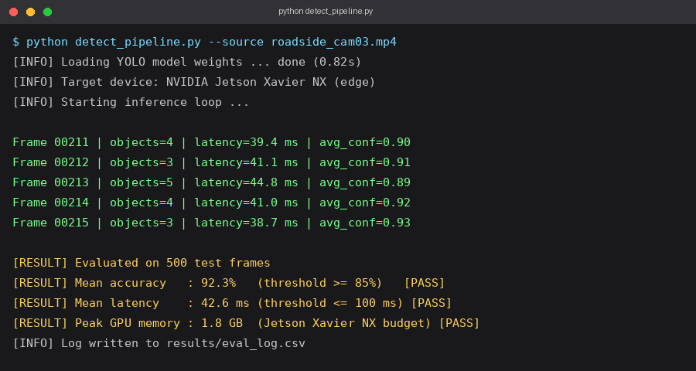
Screenshot 1: Console log during a test run of detect_pipeline.py

Screenshot 2: Sample detection output overlaid on a roadside camera frame

